RIPHAH INTERNATIONAL UNIVERSITY


Faculty of Computing
Object Oriented Programming Lab
Lab 7
Inheritance and its types
Submitted By: Khadija Binte Asif
SAP ID: 77954
Submitted To: Miss Nayab Khalid

Lab Manual Development Team

Supervision and Coordination

Hira Jaffar
Lecturer
Faculty of Computing

Lab Designers
Nayab Khalid Kayani
Lecturer
Faculty of Computing

7. Practice Tasks
- make Person (method introduce()) and Student (method study()). Call both on one Student object. (SINGLE INHERHITANCE)

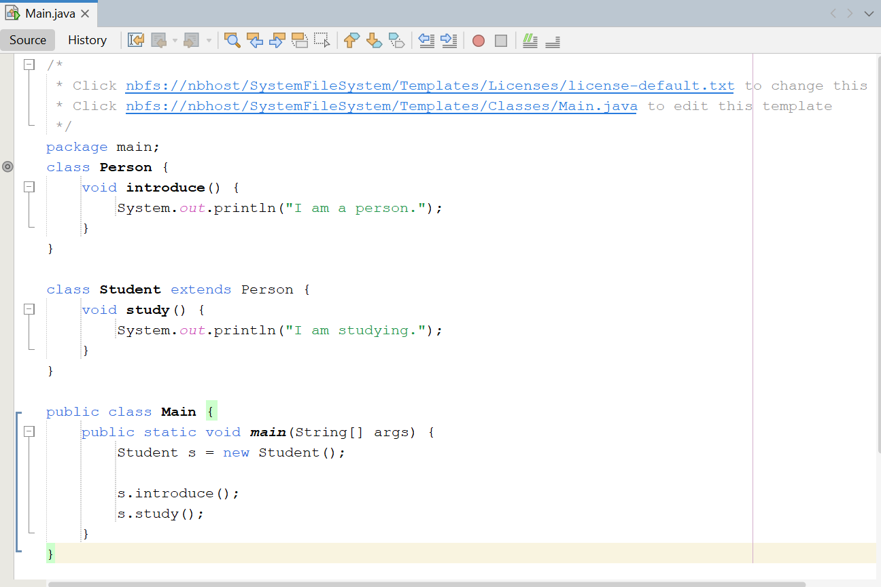

Output:
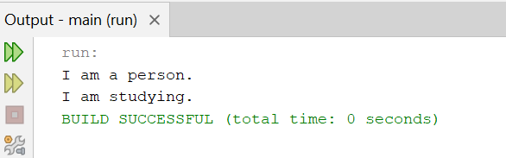

- build Grandfather → Father → Son, each with one method that prints its own name. Call all three on one Son object. (MULTILEVEL INHERITANCE)

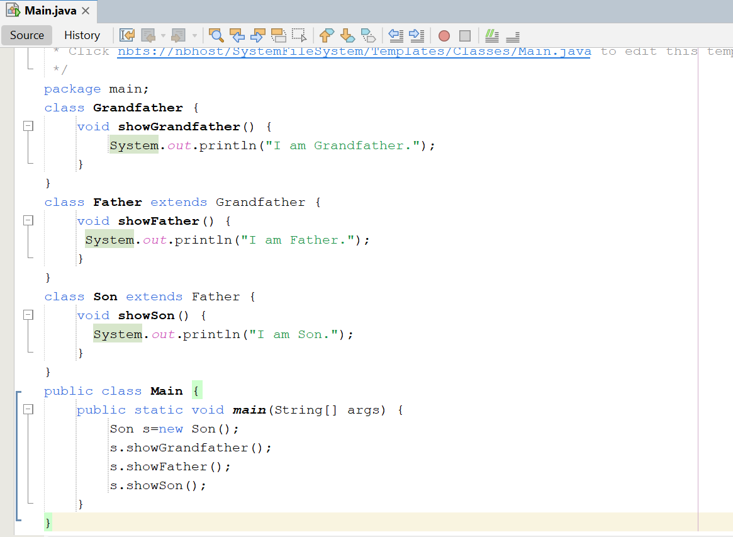

Output:
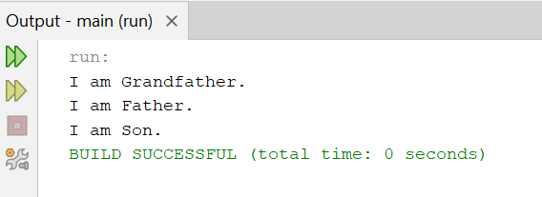

- make Employee (with showName()), then Manager and Engineer, each with its own showRole(). (HIERARCHICAL INHERITANCE)

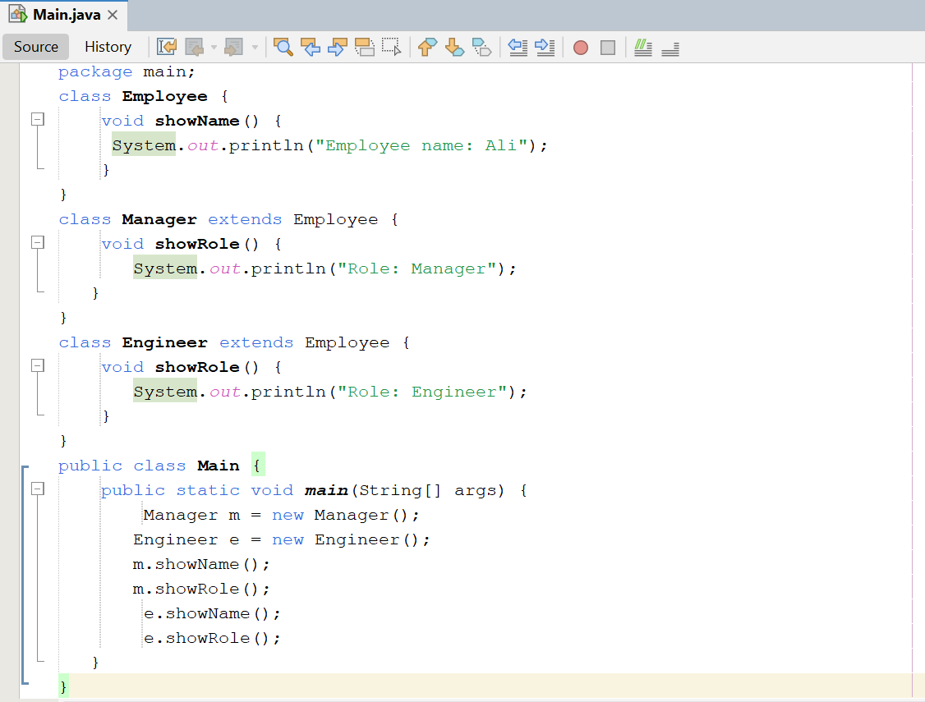

Output:
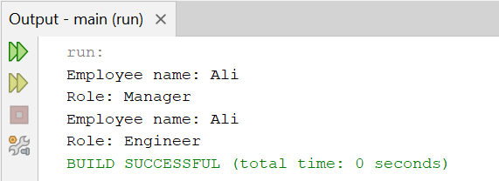

- make interfaces Printer (print()) and Scanner (scan()), then a class AllInOne that implements both. (MULTIPLE INHERITANCE)

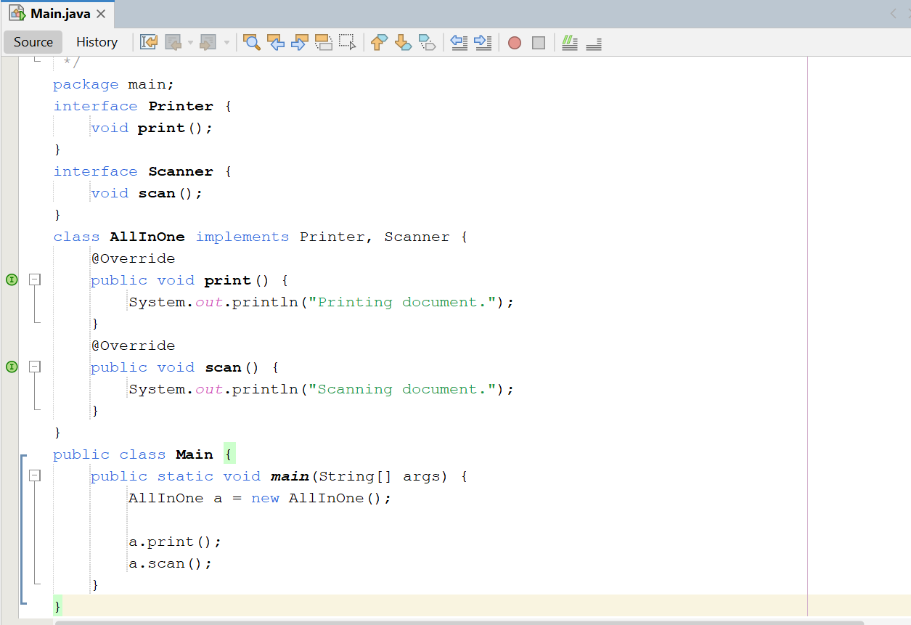

Output:
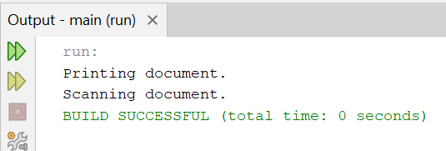

- create an interface Shape with void draw();. Make Circle and Square implement it with @Override. Store both in a Shape[] array and call draw() in a loop. (MULTIPLE INHERITANCE)

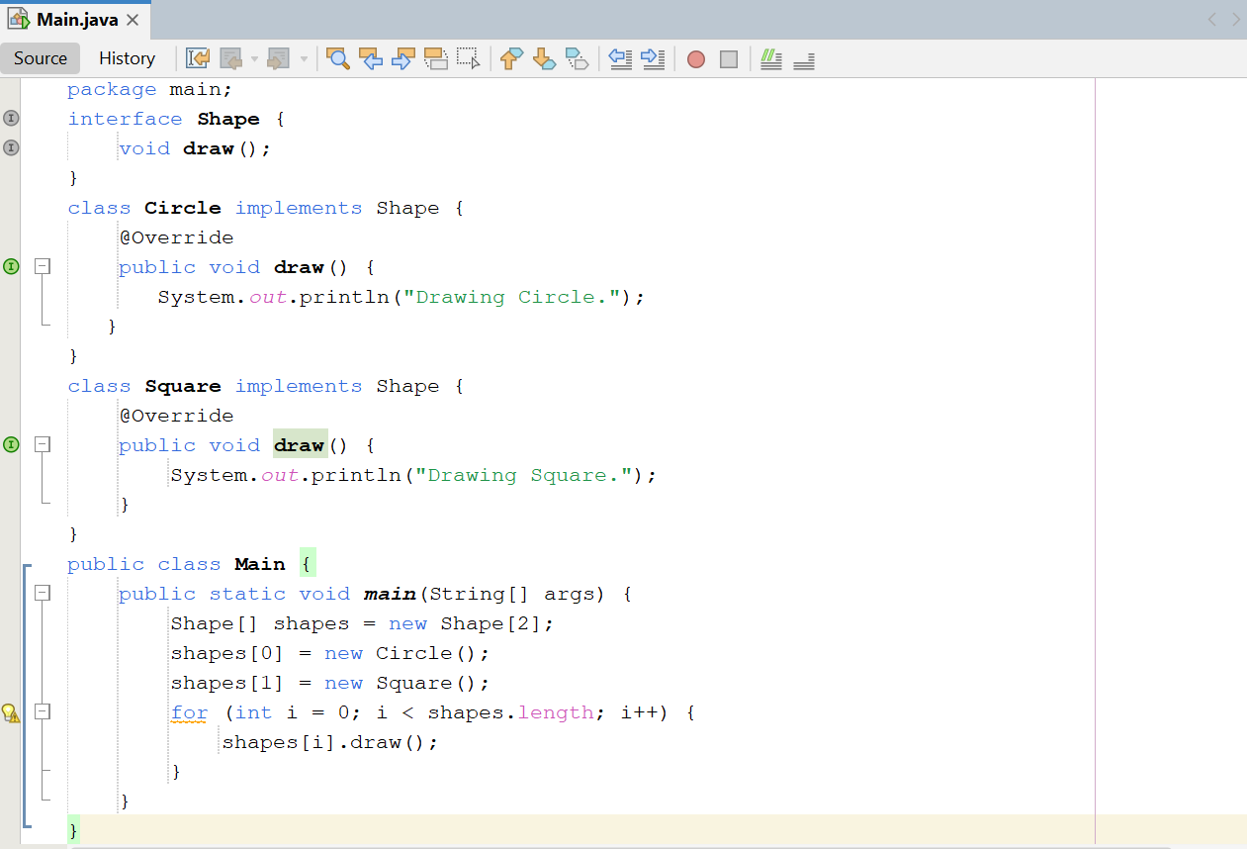

Output:

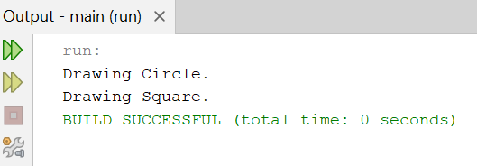

- make Employee with a constructor taking name. Make Manager call super(name) and also print a bonus line. (SINGLE INHERITANCE)

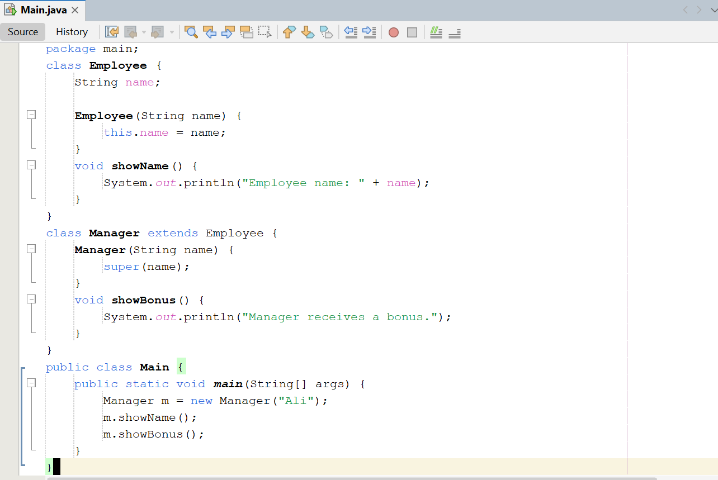

Output:
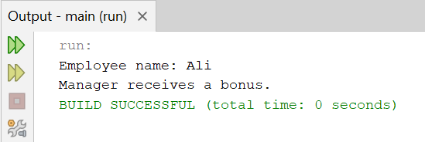

- Predict the output (do not run it first):

class A { A() { System.out.print("A "); } }
class B extends A { B() { System.out.print("B "); } }
class C extends B { C() { System.out.print("C "); } }
public class Main {
public static void main(String[] args) { new C(); }
}

Output:
A B C

